38.31: 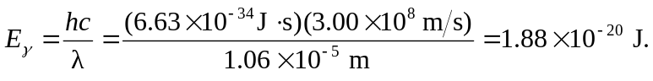

Total energy in 1 second from the laser 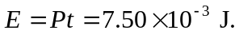 So the number of photons emitted per second is 